**Release 2 Sequential File exercise**

**CRSQFILE.cbl**

Creates a sequential file and enter the record in It.

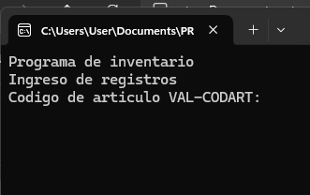

You enter 1 by 1 the data of the record.

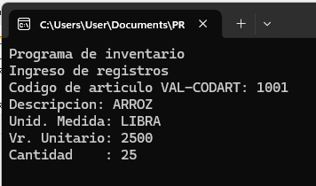

You can enter one or more records in the file.

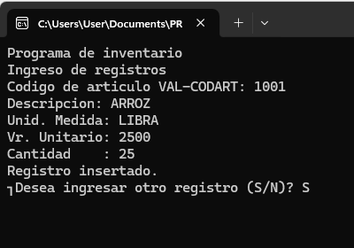

Validates if a code has previously entered.

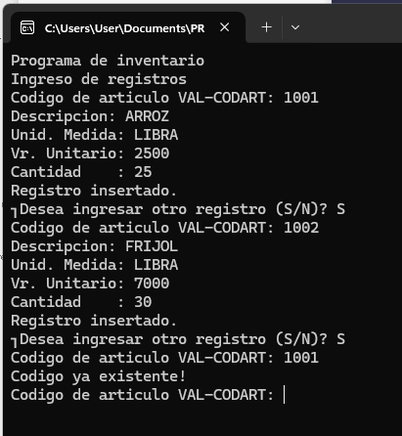

Sequential file created:

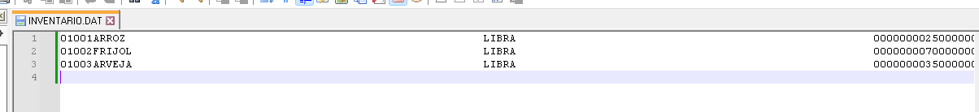

**RDSQFILE.cbl**

Reads the sequential file and displays on the screen.

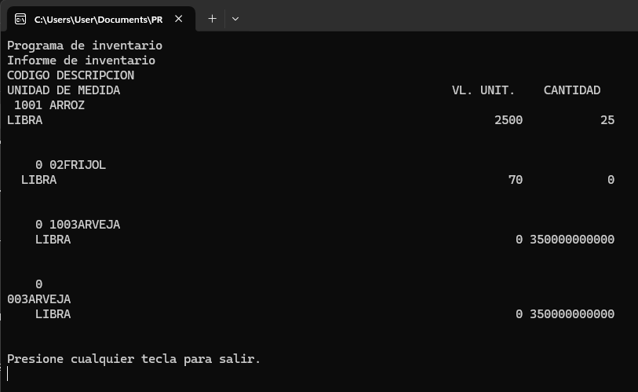

**SCHRCFIL.cbl**

Purpose: Search for a single record in the sequential file with data formatted.

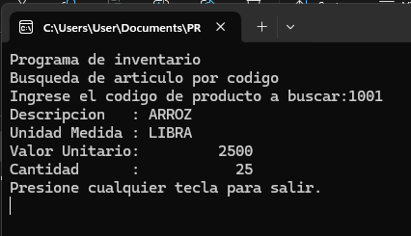

**URSQFILE.cbl**

Purpose: Updates a record in the sequential file.

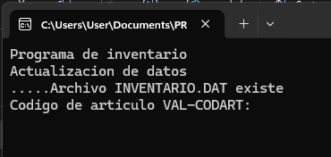

Validates if code is not null.

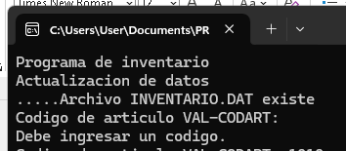

Updates data in record:

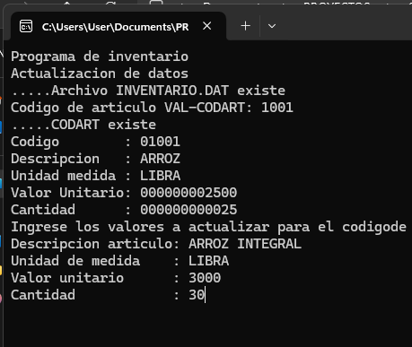

File updated.



**DRSQFILE.cbl**

Purpose: Deletes a record in the sequential file and updates the previous sequential file.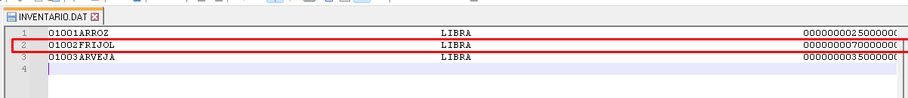

Execution.

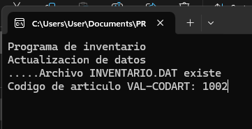

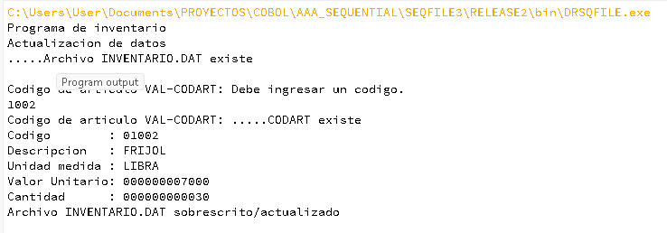



**CRSQCSV.cbl**

Purpose: Reads data in sequential file and creates another file with csv format.

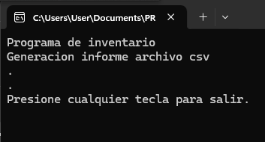

File created:

